**Approve Employee Leave Requests**

Approving employee leave requests is a critical workflow for managers to ensure proper staffing and compliance with company policies. The leave approval process enables L1 and L2 managers to review, approve, or reject leave requests, examine supporting documents, and assess leave utilization. This procedure covers how to access pending leave requests, review details, approve or reject requests, customize the approval table, and export or filter leave data for further analysis.

**To approve employee leave requests**

1. Navigate to **My Applications** and select **Leave & Attendance**.

The Leave in Attendance section opens, displaying leave management options.

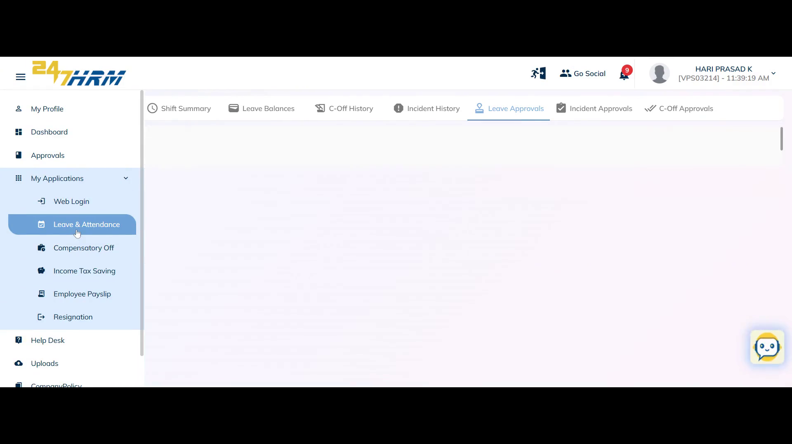

2. Click the **Leave Approvals** tab.

The Leave Approvals tab displays a section for pending approvals.

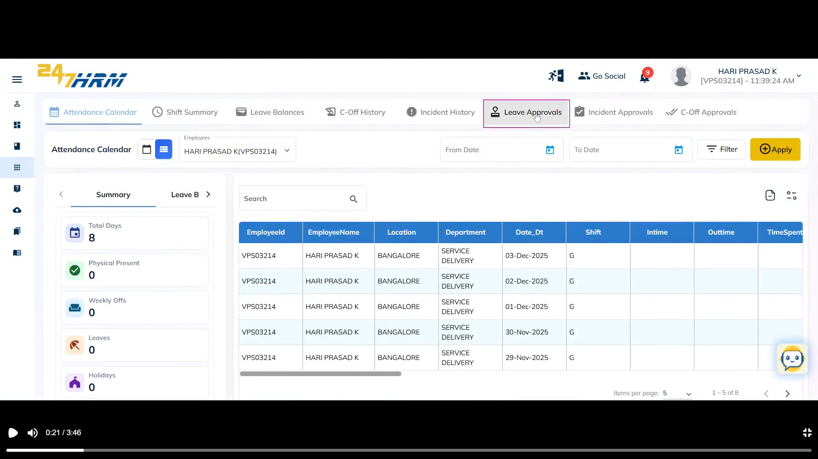

3. Review the **Pending Approvals** section.

A table lists employees with leave requests awaiting approval, showing details such as employee name, leave type, From Date, To Date, number of days, reason for leave, recommendations, reason for reject, documents and Actions.

**Note:** The **Reason for Reject** column displays the rejection reason provided by the manager, based on the leave approval flow.

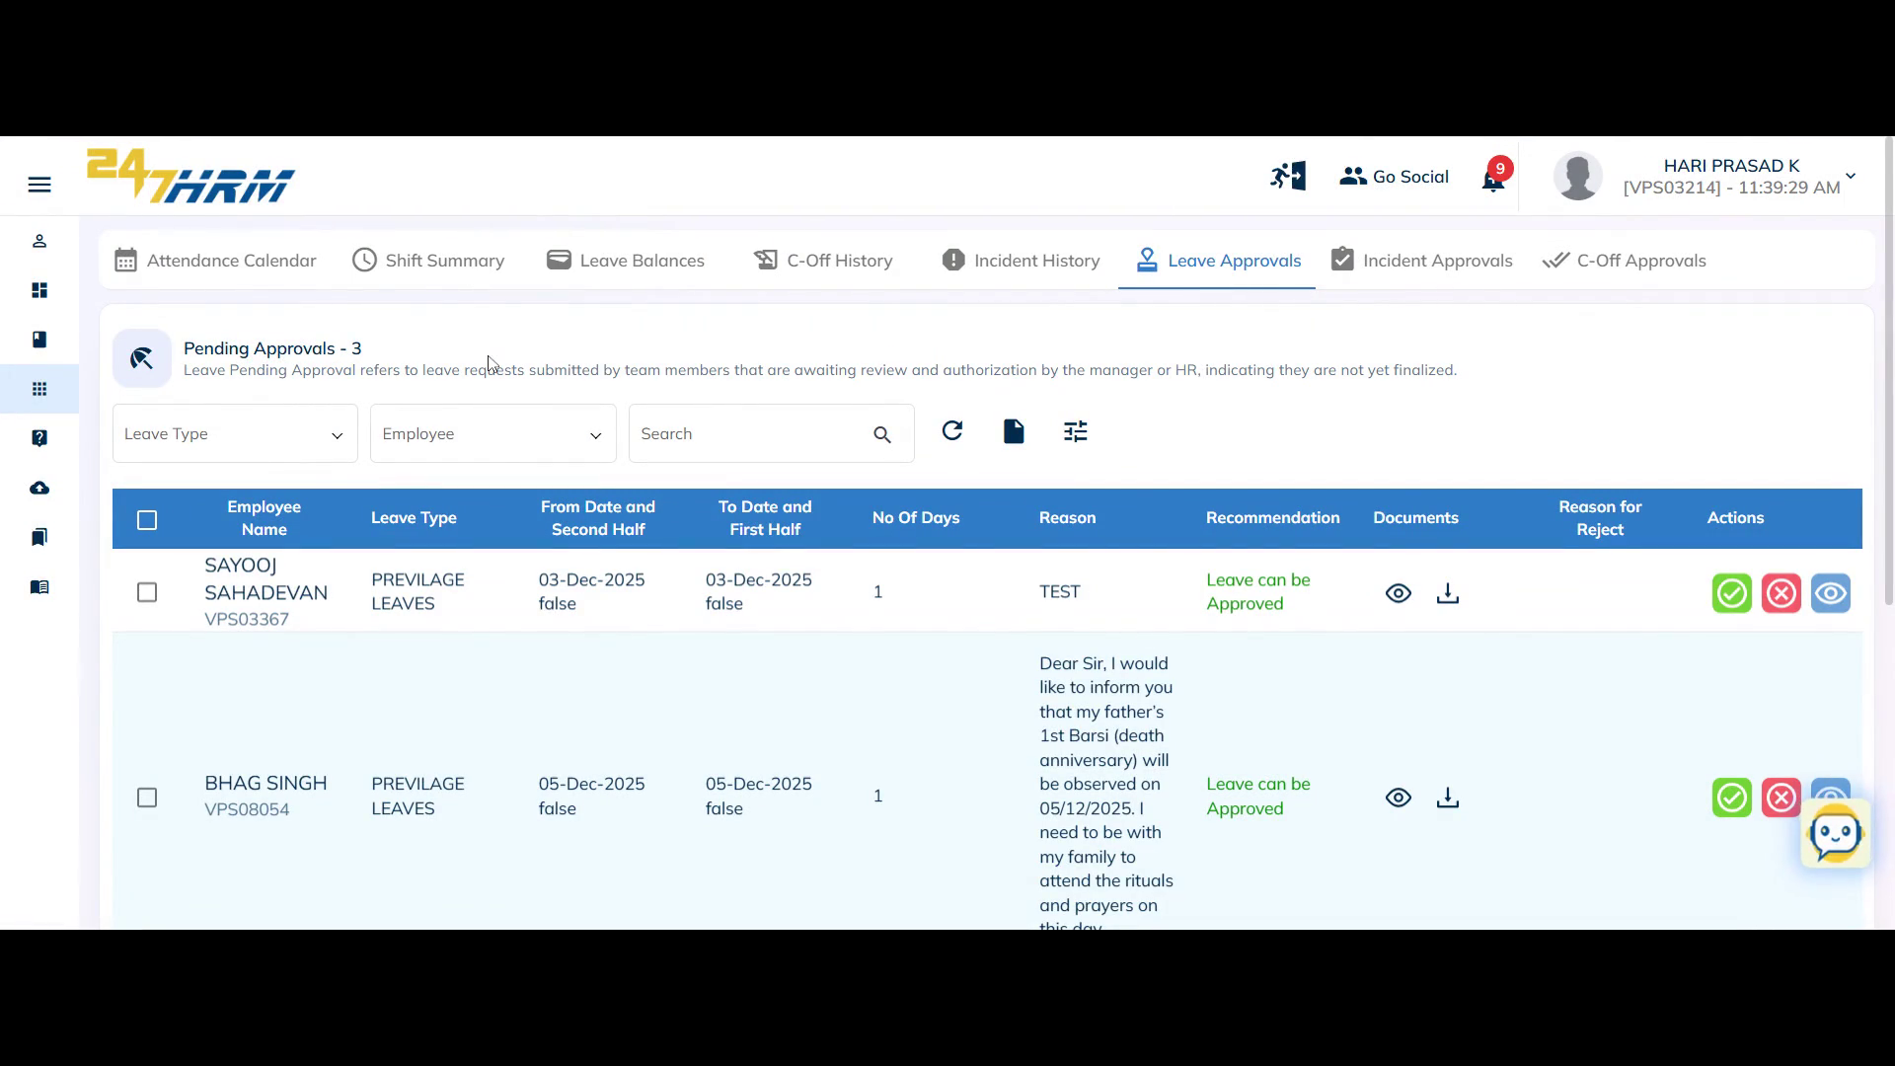

4. In the **Actions** column, choose to **Approve**, **Reject**, or **View Request** for each leave entry.

You can take action on individual leave requests.

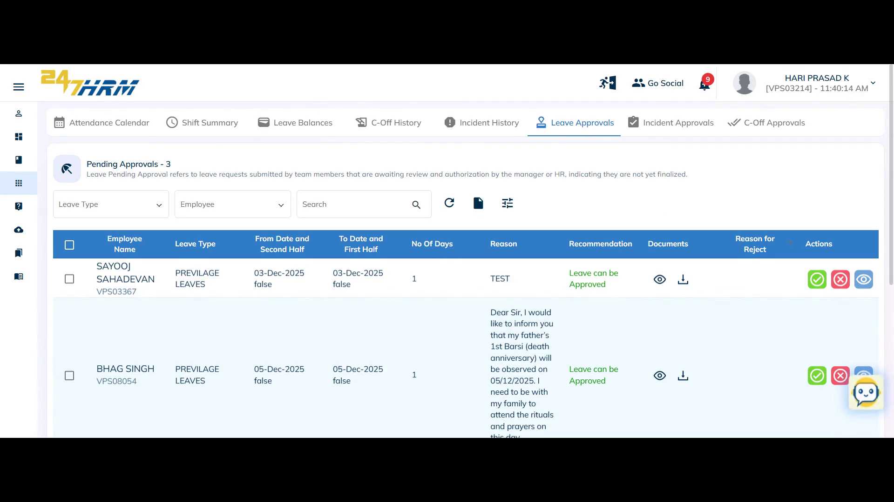

5. (Optional) Click **View Request** to see all leave details for a specific employee.

The leave request details open, showing comprehensive information about the request.

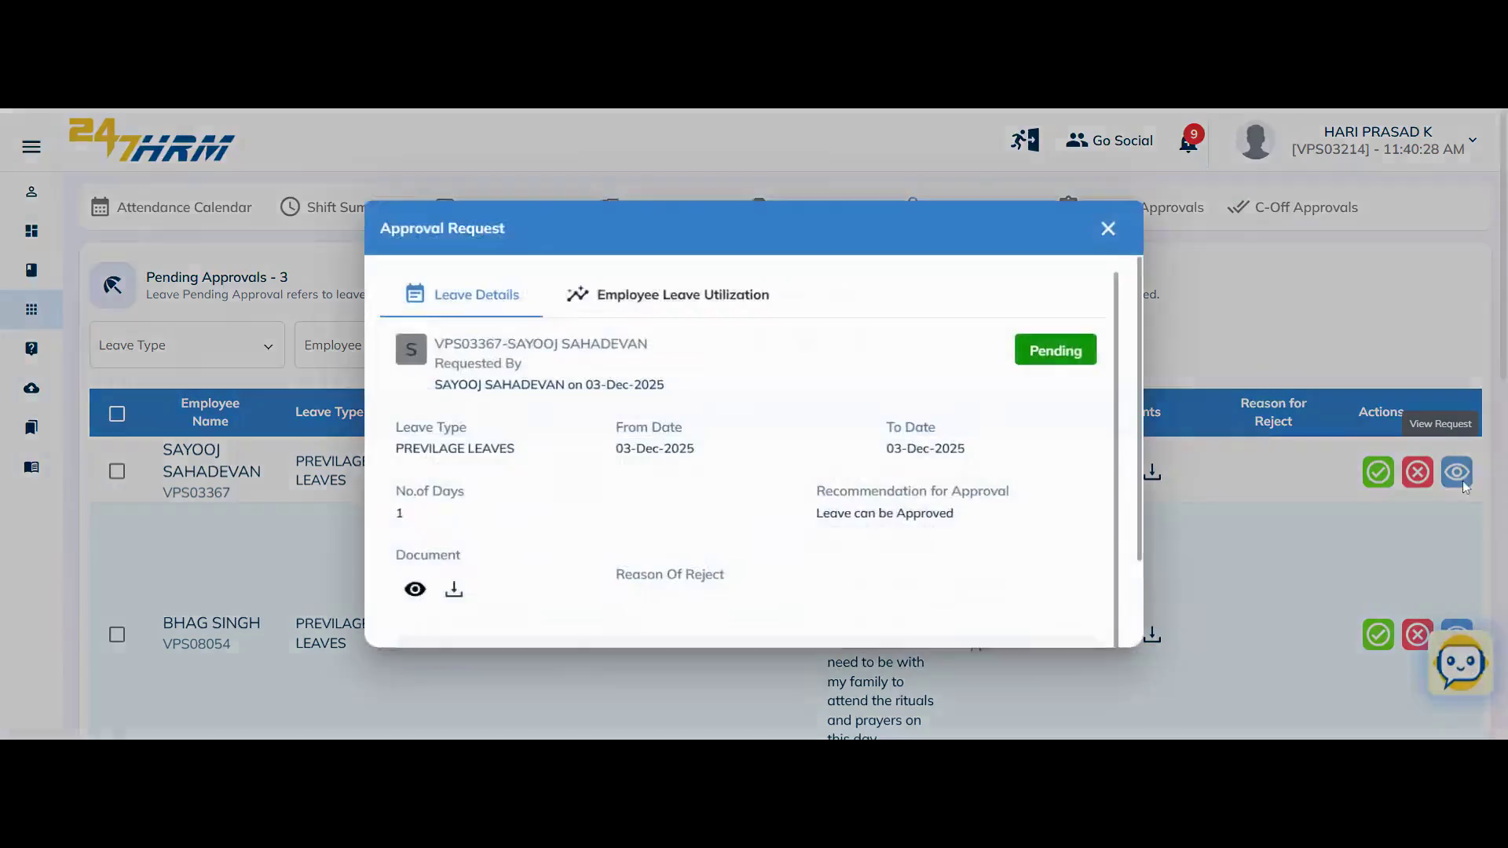

6. (Optional) Select the **Employee Utilization** tab to view the employee's leave usage for the current month.

The system displays the number and types of leaves taken by the employee in the current month by default.

**Note:** To review leave taken in the past three months, check the utilization summary (e.g., two privileged leaves used).

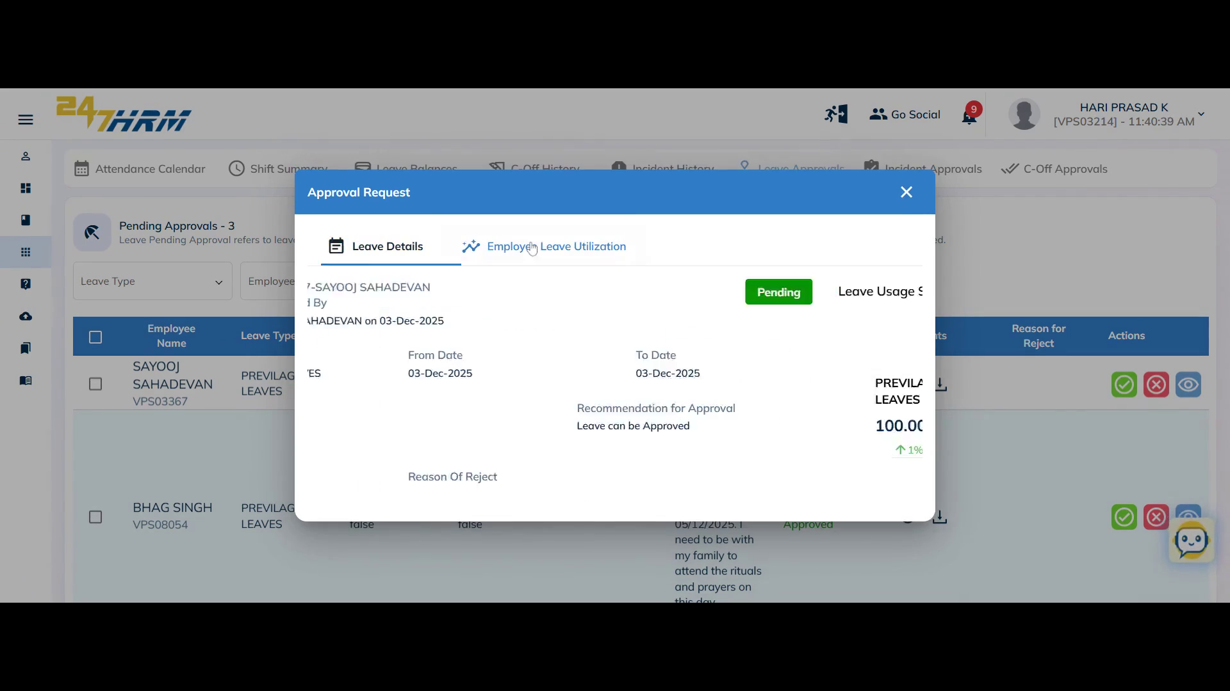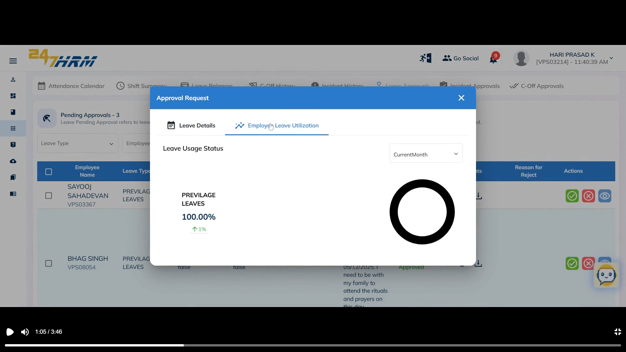

7. To approve a leave request, click the **Approve** button in the Actions column.

The system confirms the leave is approved (e.g., for Sayooj Sahadevan).

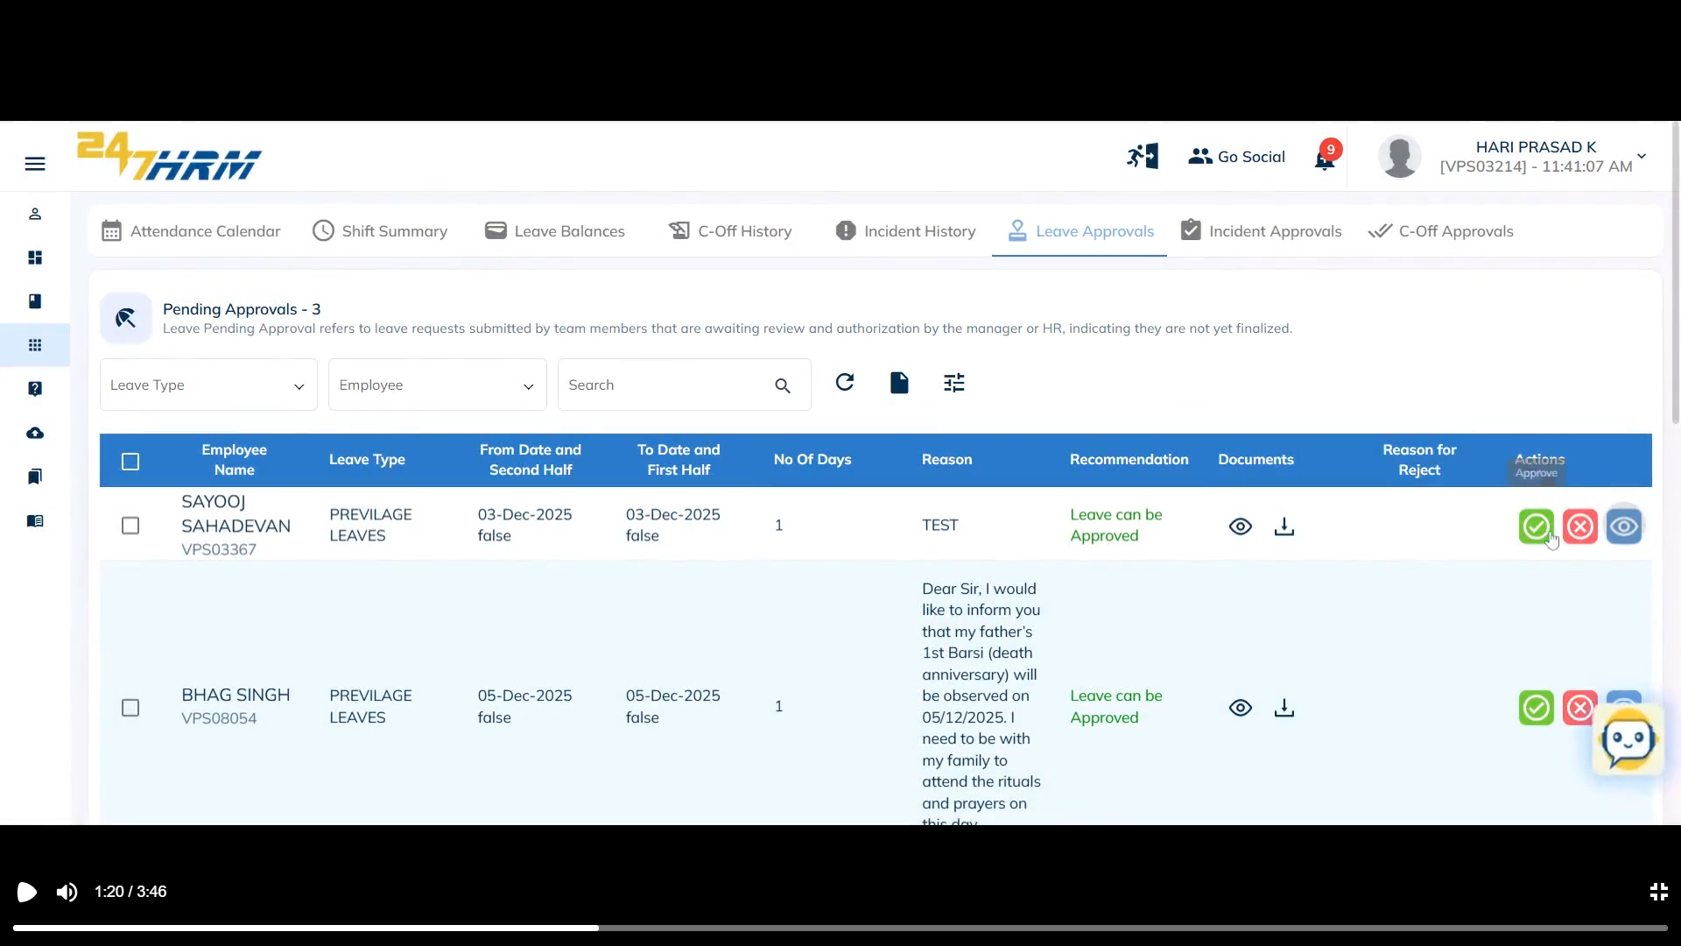

8. (Optional) Customize the table by hiding columns, such as the employee name column.

The selected columns are hidden from the table view.

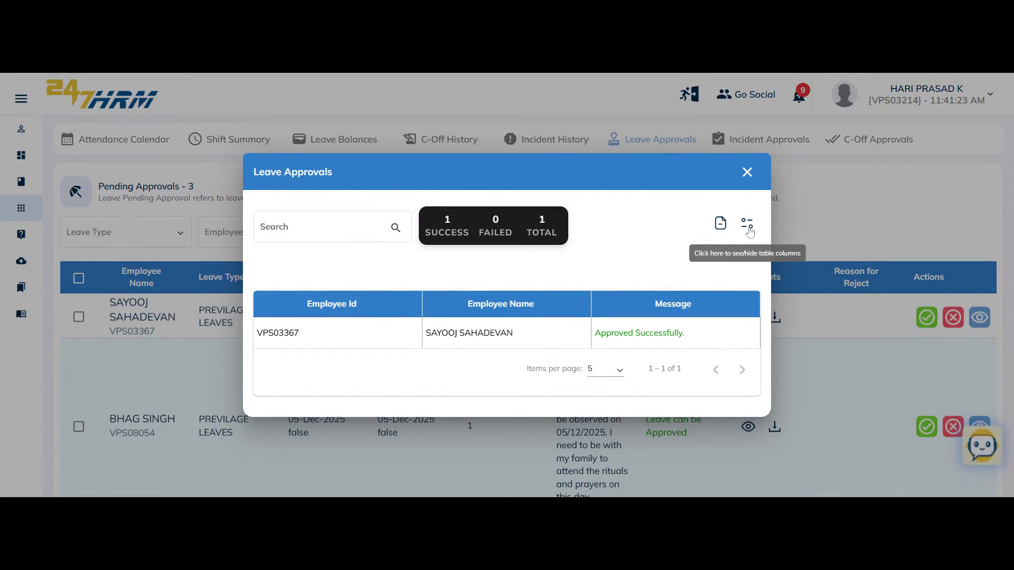

9. (Optional) Export the table as an Excel file by clicking **Generate Excel**.

The leave approval data is downloaded in Excel format for further analysis.

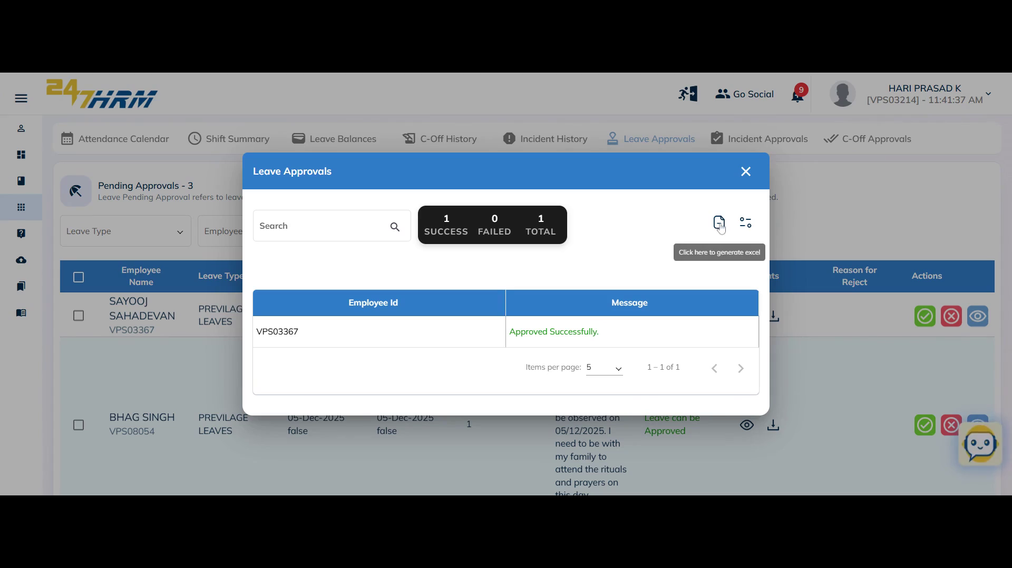

10. (Optional)Search for a specific leave type or employee name using the search bar above.

The table updates to display only matching records.

**Note:** Use filters such as leave type or employee name to refine your search.

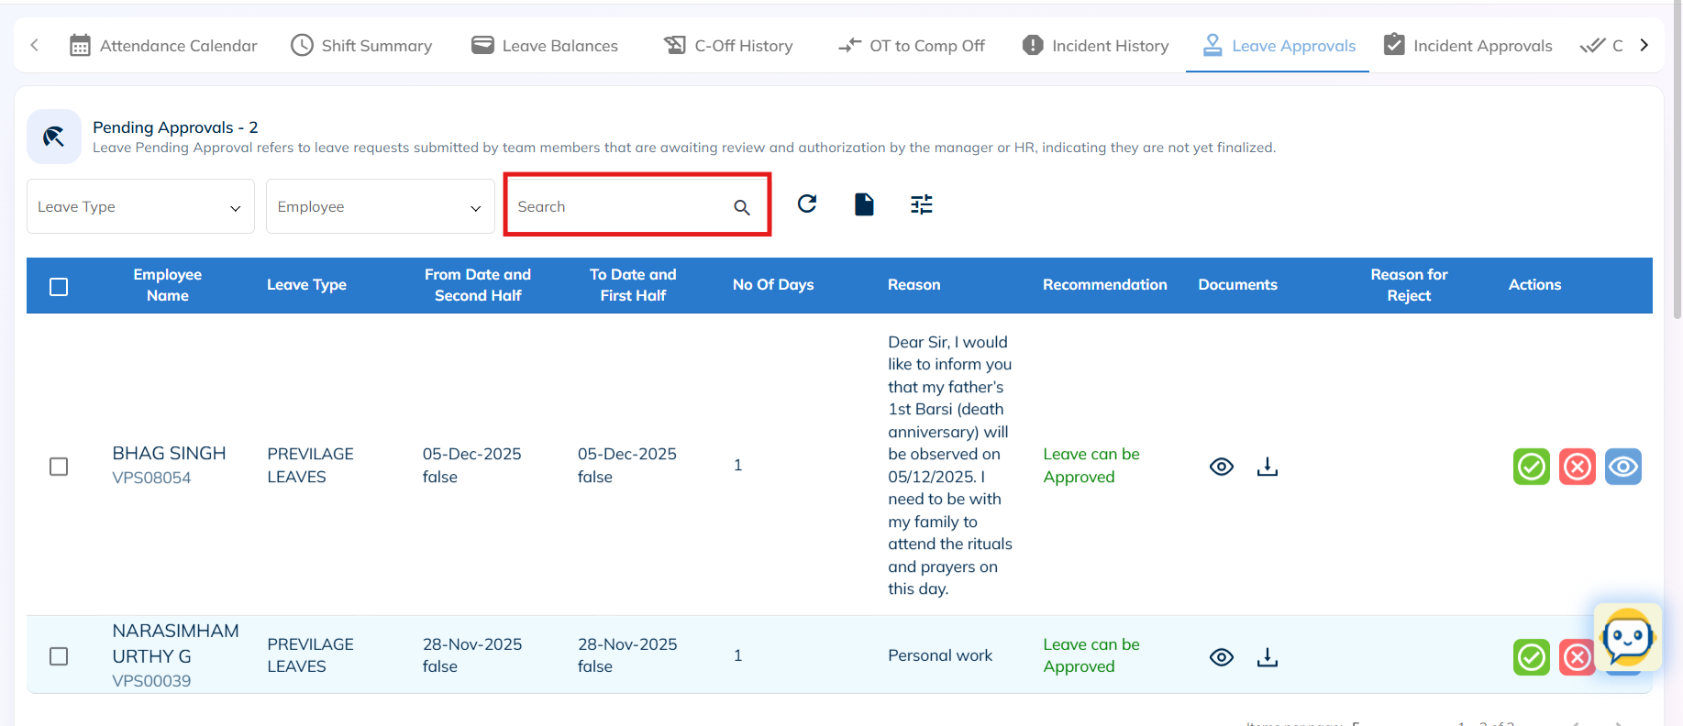

11. (Optional) Download or view documents submitted by employees with their leave requests.

You can access supporting documents for review or download them as needed.

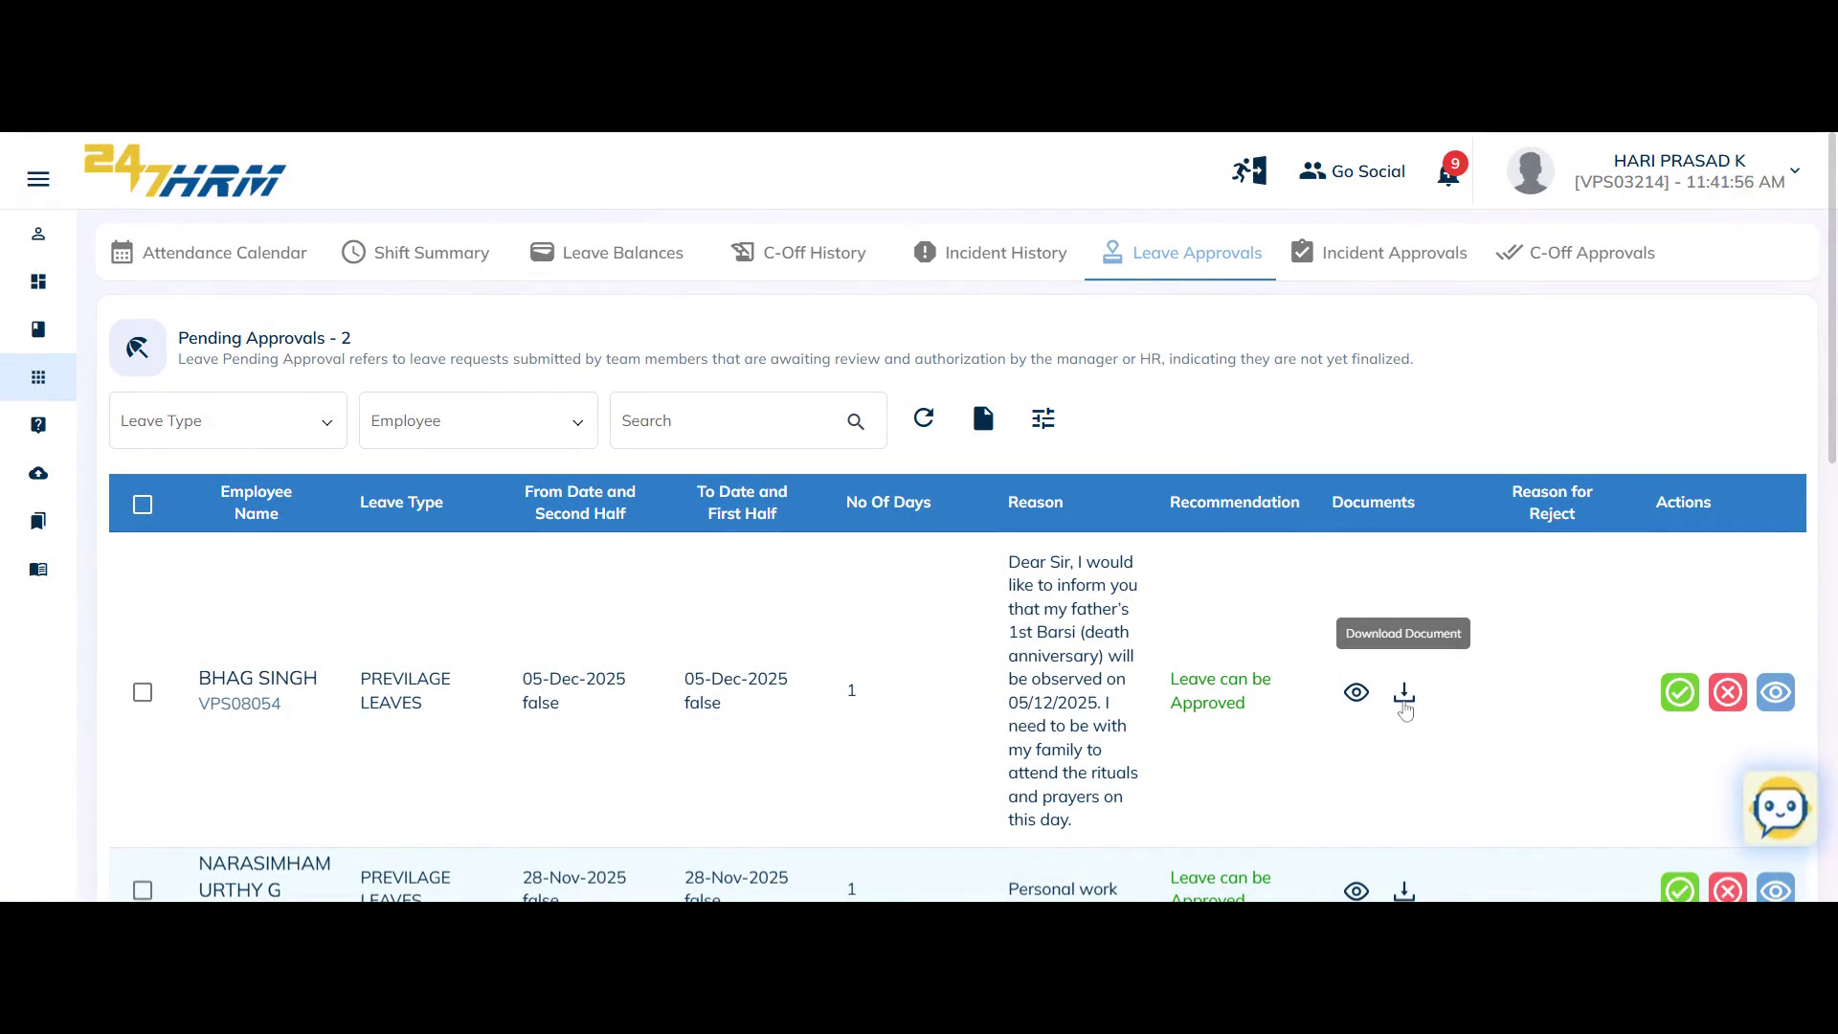

12. Scroll down to the **Approved History** section to view leaves already approved for each employee.

The section lists employee name, leave type, application date, leave date, reason, recommendation, and number of days taken.

**Note:** You can review or download the attached documents from this section as well.

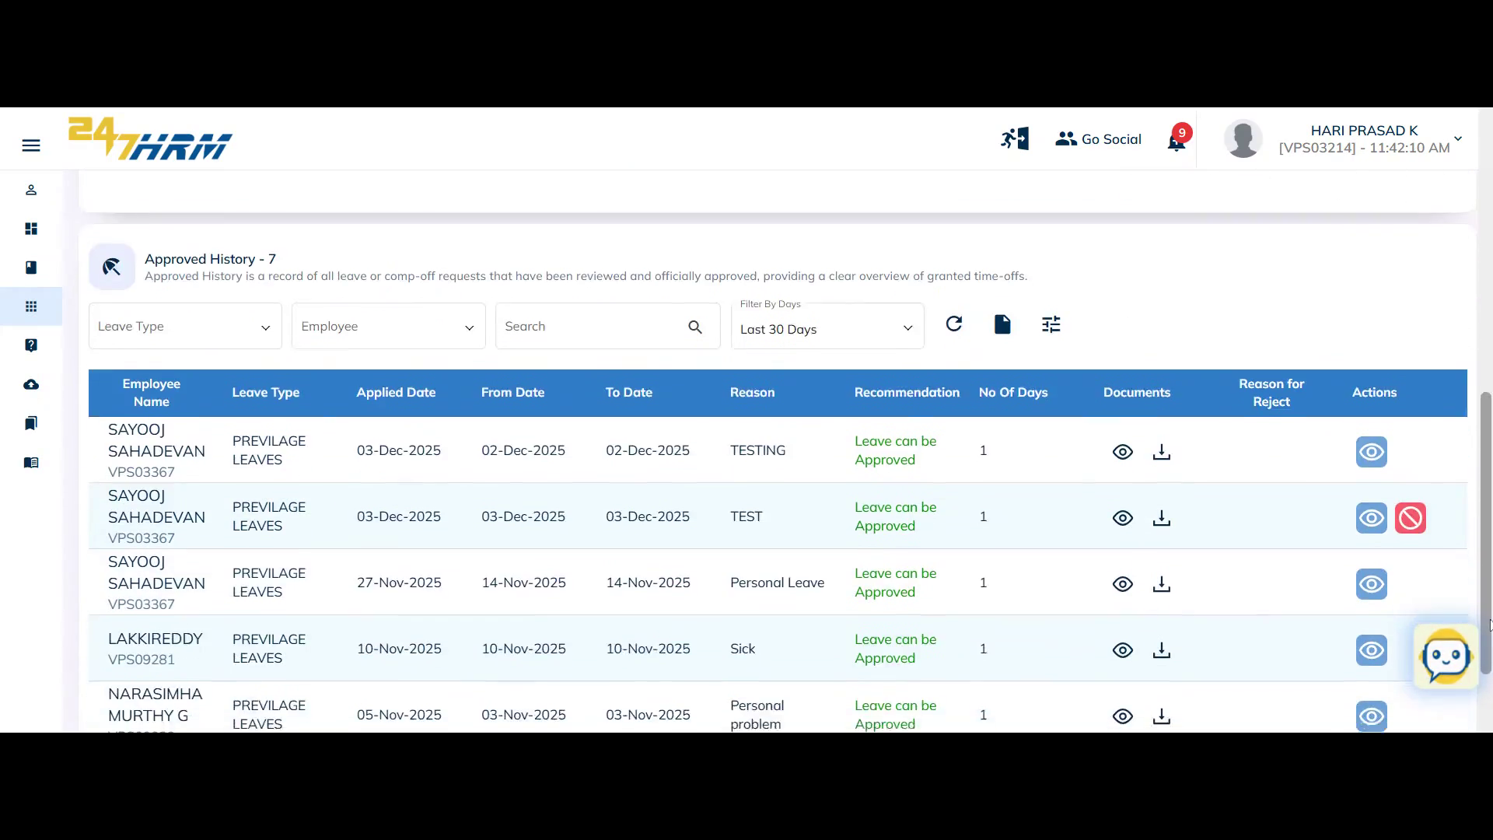

13. (Optional) If the L1 Manager rejects a leave request, the **Reason for Reject** column displays the rejection reason.

The leave details can be viewed in the **Actions** column for further review.

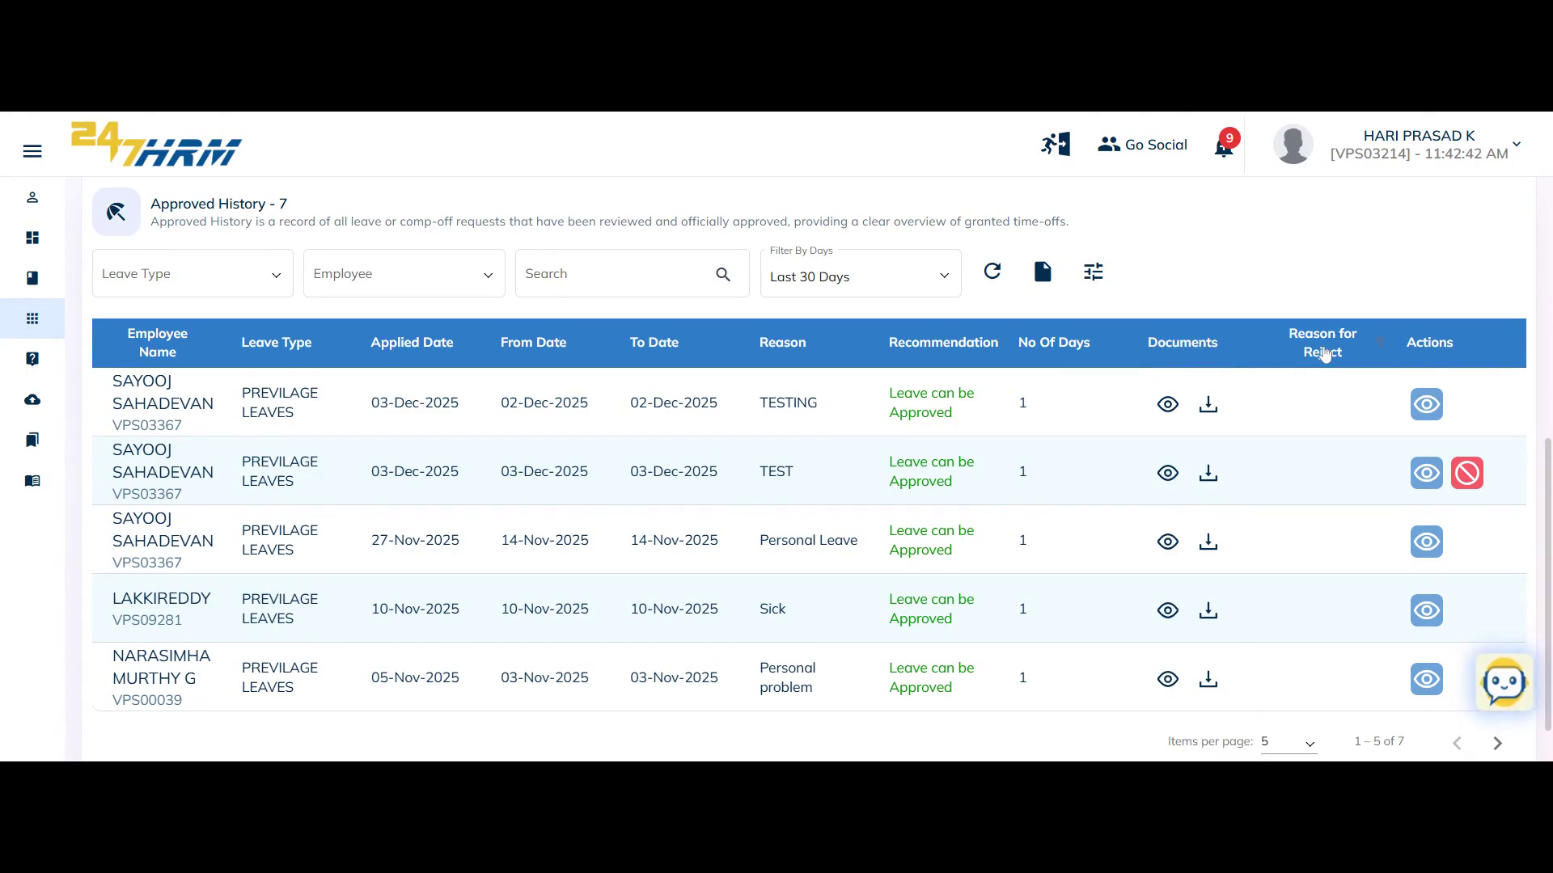

14. (Optional) Use the **Employee Leave Utilization** tab to display the number of leaves taken by an employee in a selected period.

By default, the current month's data is shown (e.g., two privileged leaves taken).

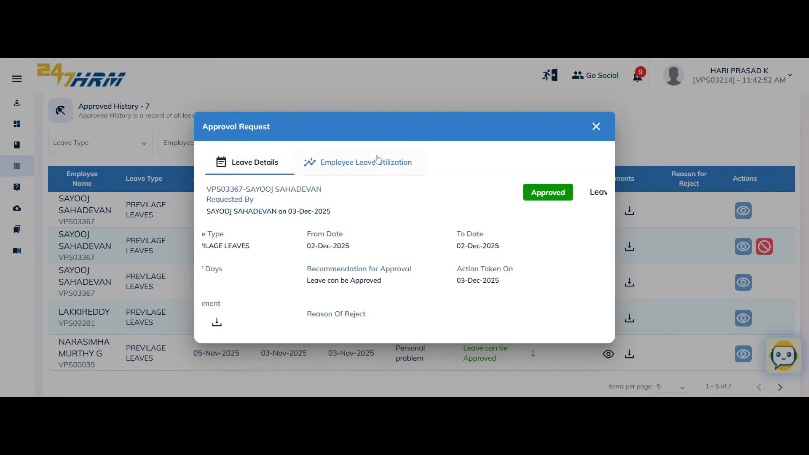

15. (Optional) Click **Cancel** to exit the approval process or hide columns (e.g., recommendation or reject reason) from the table view.

The selected columns are removed from the display.

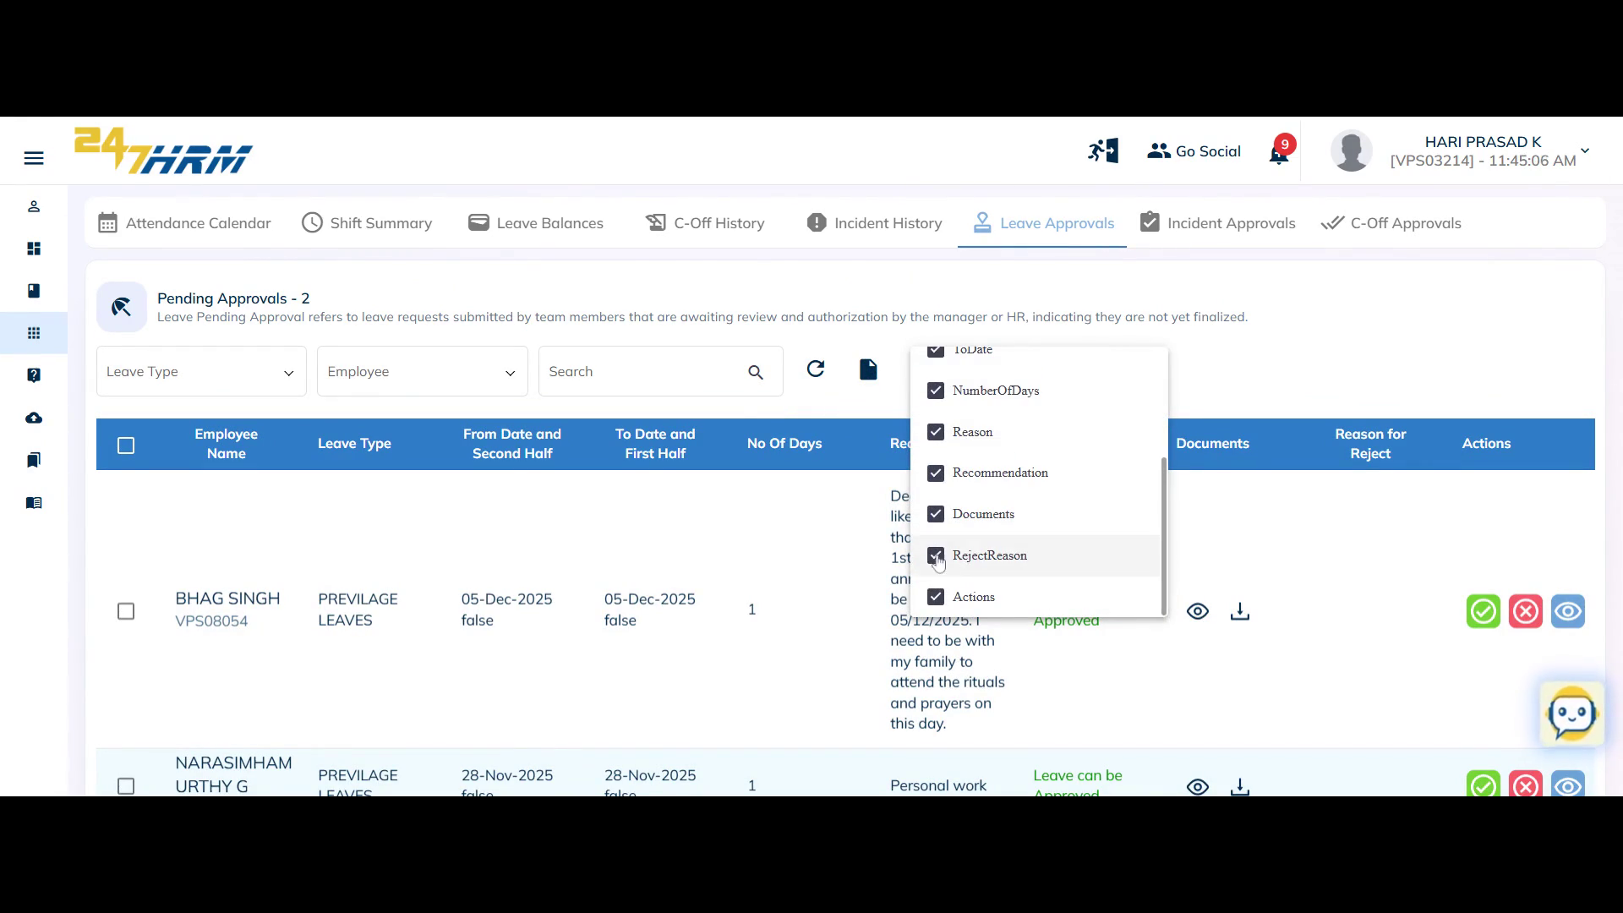

16. (Optional) Reset filters and download the data as an Excel file for further review.

The table resets to show all records, and the data is exported as needed.

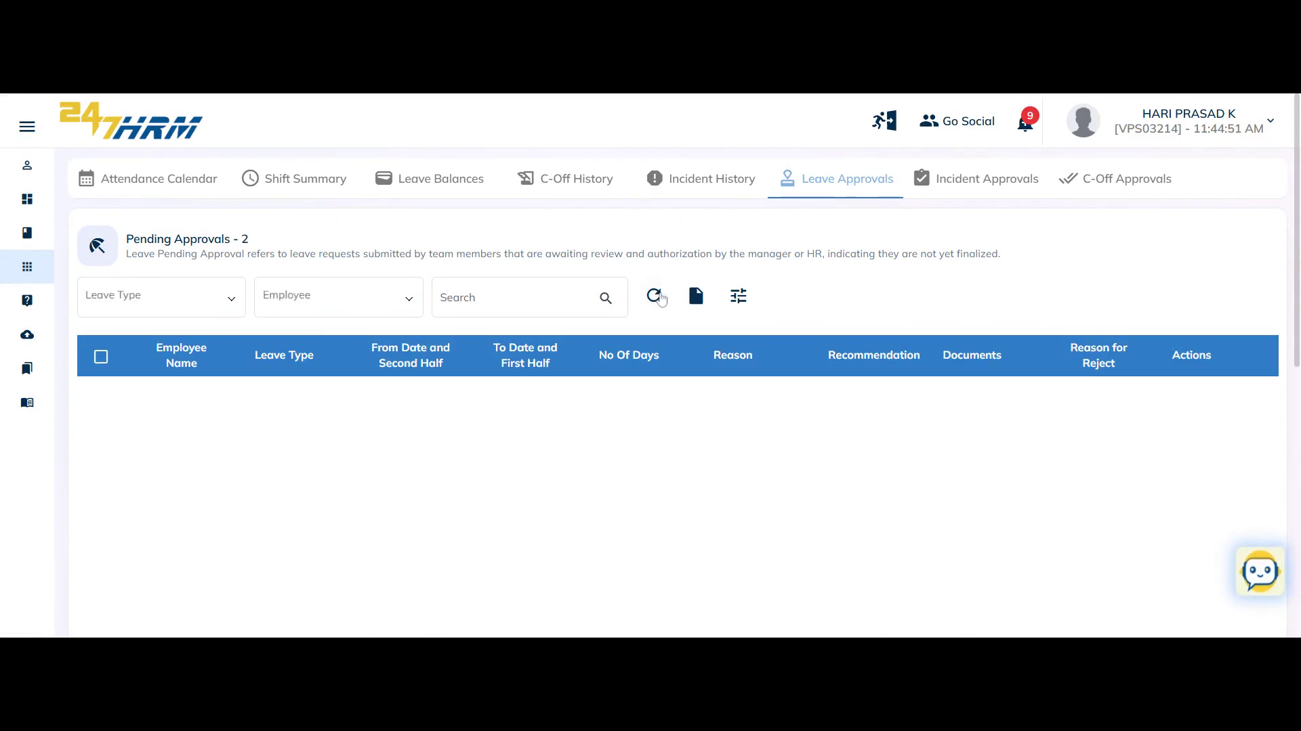

17. (Optional) If there are no pending approvals, the **Pending Approvals** section will be empty.

No leave requests are awaiting action.

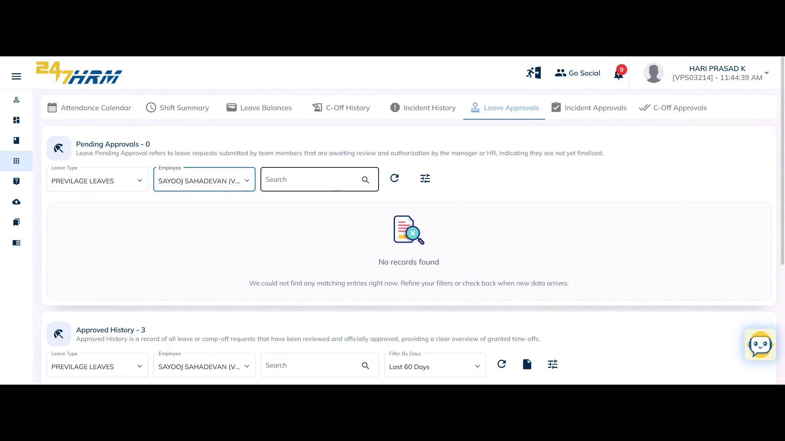

**Troubleshooting Guide**

**Leave Approval Workflow: Approving or Rejecting Employee Leave Requests**

**Problem**

Managers need to review and take action on employee leave requests within the 247 HRM portal. The process involves viewing pending requests, examining supporting documents, and either approving or rejecting the leave. This guide addresses how to access, review, and process leave approvals, as well as how to customize and export leave data for further analysis.

**Solution**

The leave approval process consists of several key actions:

• **Accessing Pending Leave Requests:** Navigate to the appropriate section to view requests awaiting your approval.

• **Reviewing Leave Details:** Examine employee leave information, supporting documents, and leave utilization.

• **Approving or Rejecting Requests:** Take action on each leave request, providing reasons for rejection if necessary.

• **Customizing and Exporting Data:** Adjust table views, apply filters, and export data for reporting or analysis.

• **Reviewing Leave History:** Check approved leave history and utilization for each employee.

Each step can be performed independently or in sequence, depending on your workflow needs.

**To access and review pending leave requests**

1. Navigate to **My Applications** in the system.

The main applications dashboard appears.

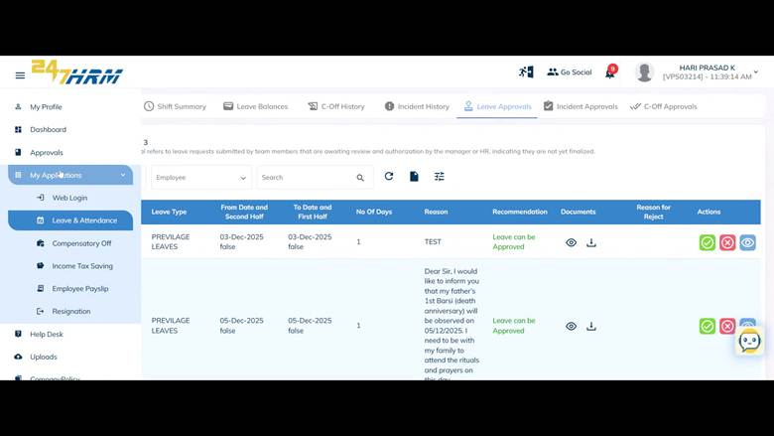

2. Select **Leave & Attendance**.

The Leave and Attendance section opens.

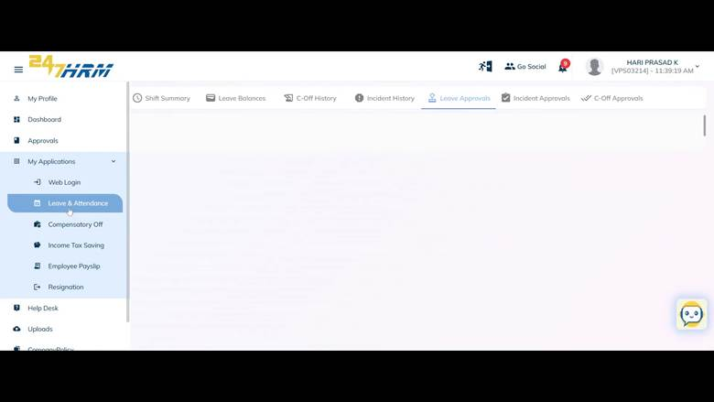

3. Open the **Leave Approvals** tab.

The Leave Approvals tab displays a section for pending approvals.

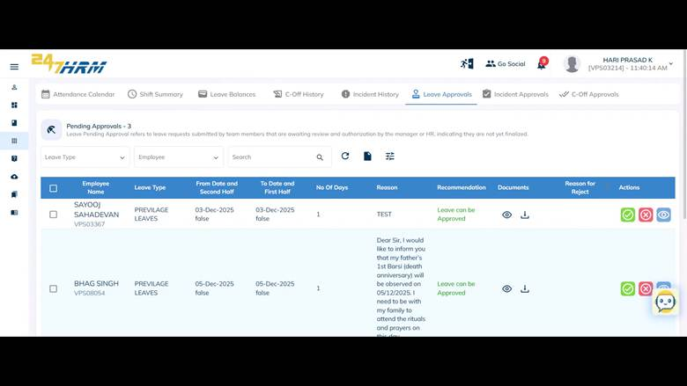

4. Review the list of employees with pending leave requests.

The table shows details such as employee name, leave type, duration, number of days, reason for leave, recommendations, reason for reject and submitted documents.

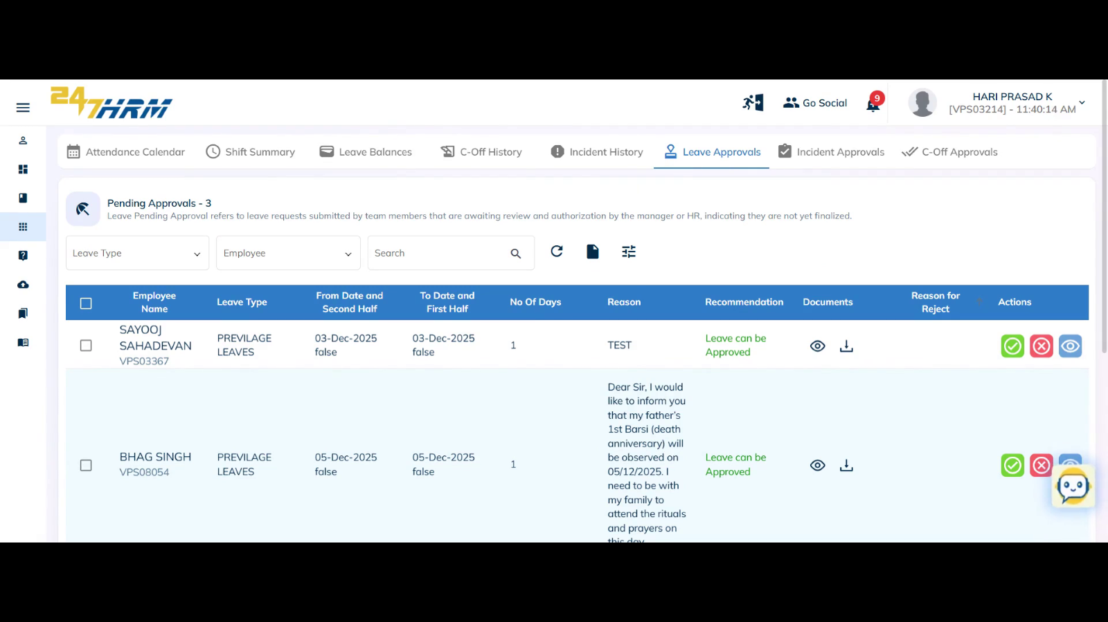

5. In the **Actions** column, choose to **Approve**, **Reject**, or **View Request** for each leave entry.

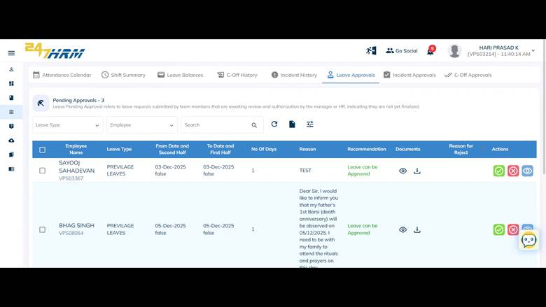

6. Click **View Request** to see all leave details for a specific employee.

The full leave request details are displayed.

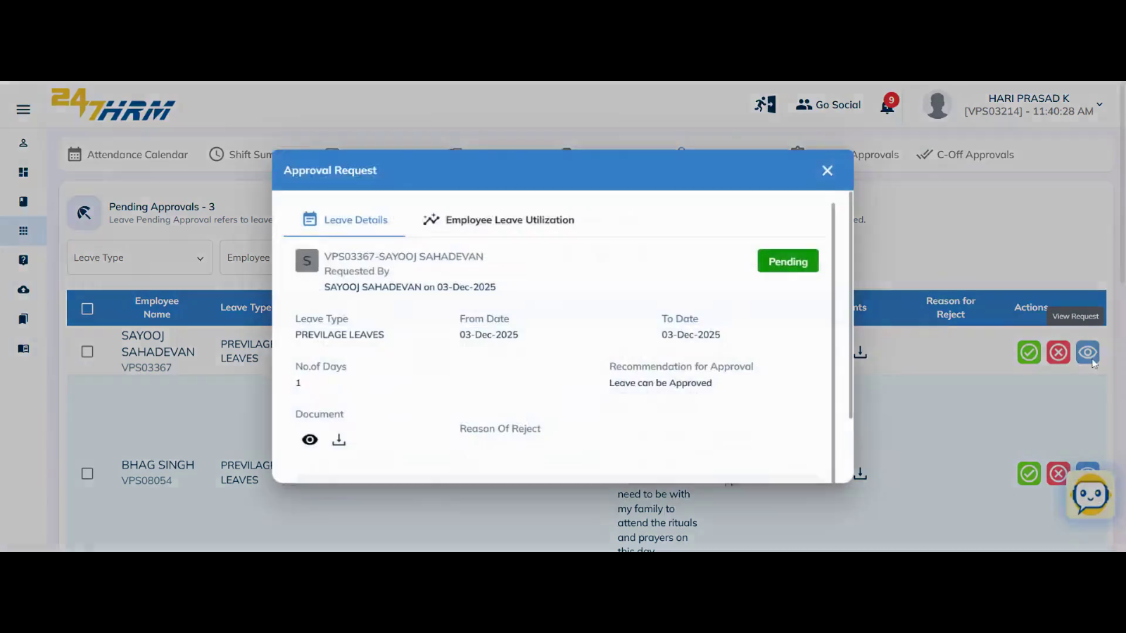

**To review employee leave utilization**

1. Select the **Employee Utilization** tab within the leave request details.

The tab displays the employee's leave usage for the current month.

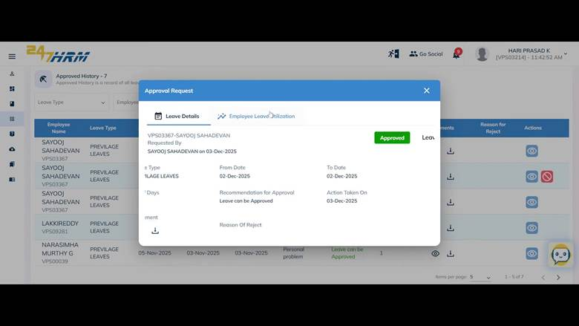

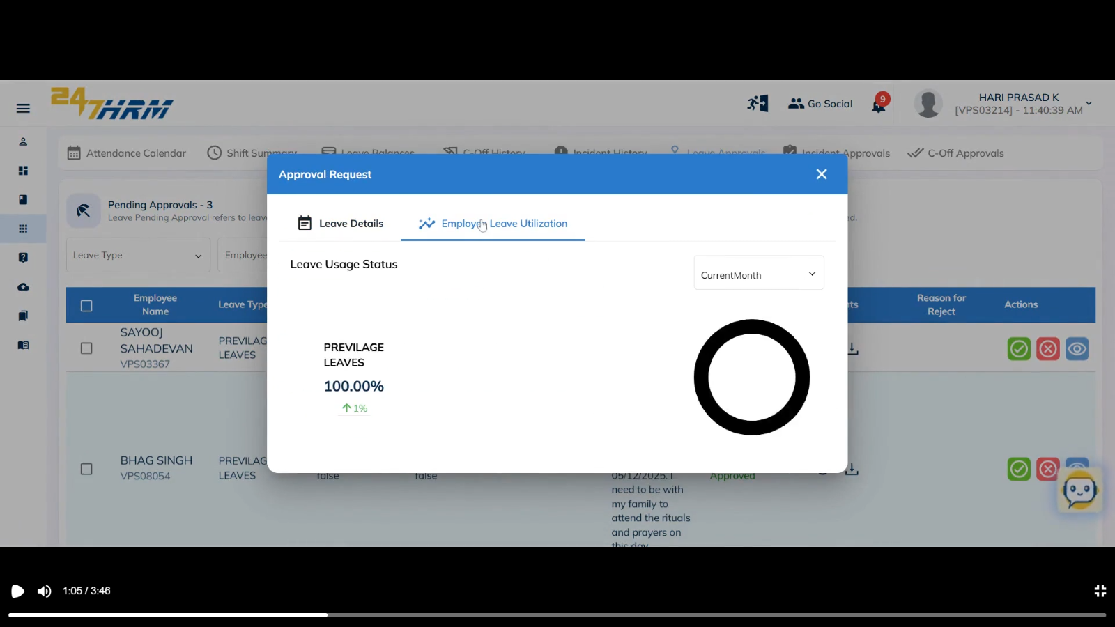

2. To review leave taken in the past three months, check the utilization summary (e.g., two privileged leaves used).

The system shows a breakdown of leave types and quantities taken in the selected period.

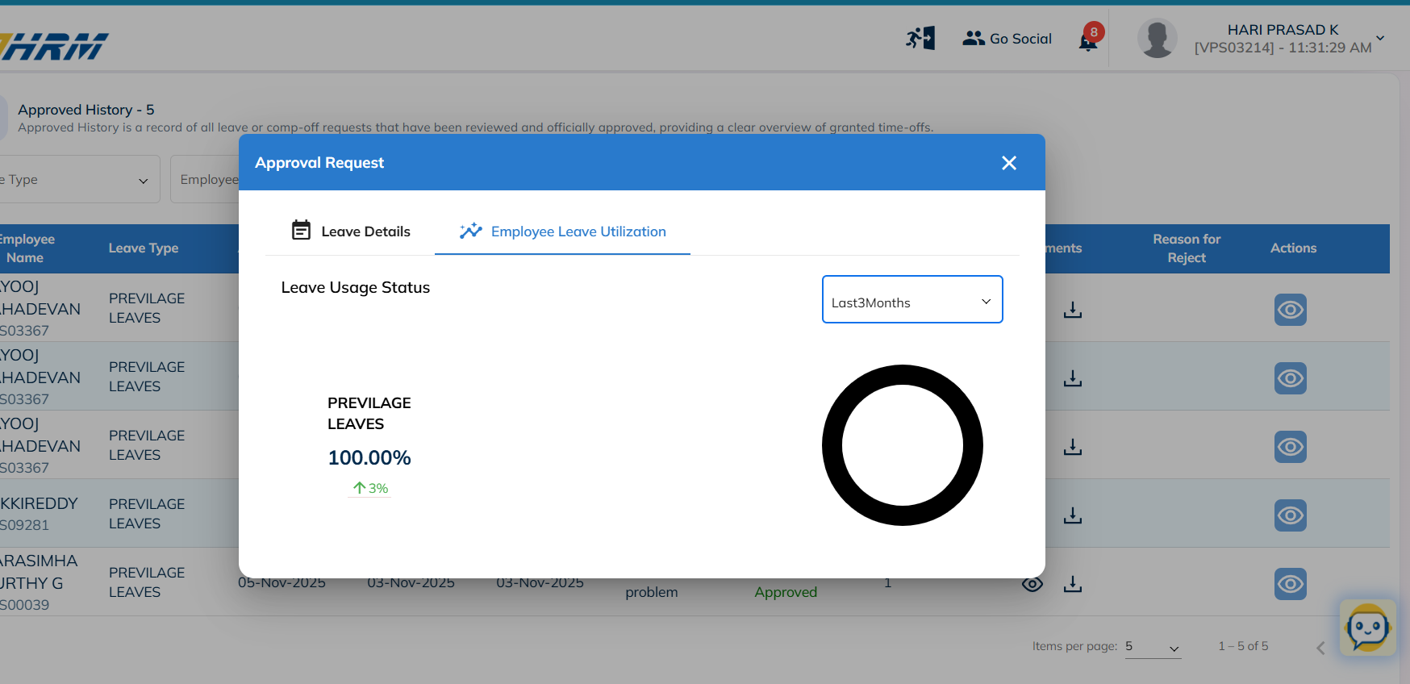

**To approve a leave request**

1. Click the **Approve** button in the Actions column for the desired leave request.

The system confirms the leave is approved (e.g., for Sayooj Sahadevan).

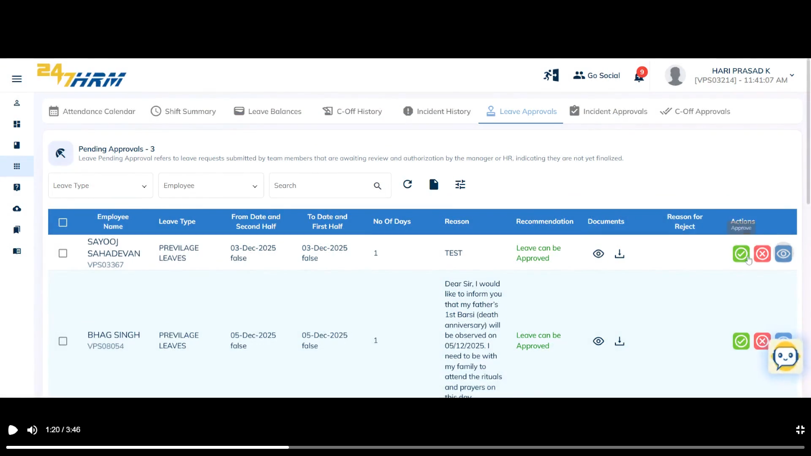

**To reject a leave request**

1. Click the **Reject** button in the Actions column for the leave request.

The system prompts for a rejection reason as configured in the leave approval flow.

**Important:** The rejection reason entered will be visible in the "Reason for Reject" column.

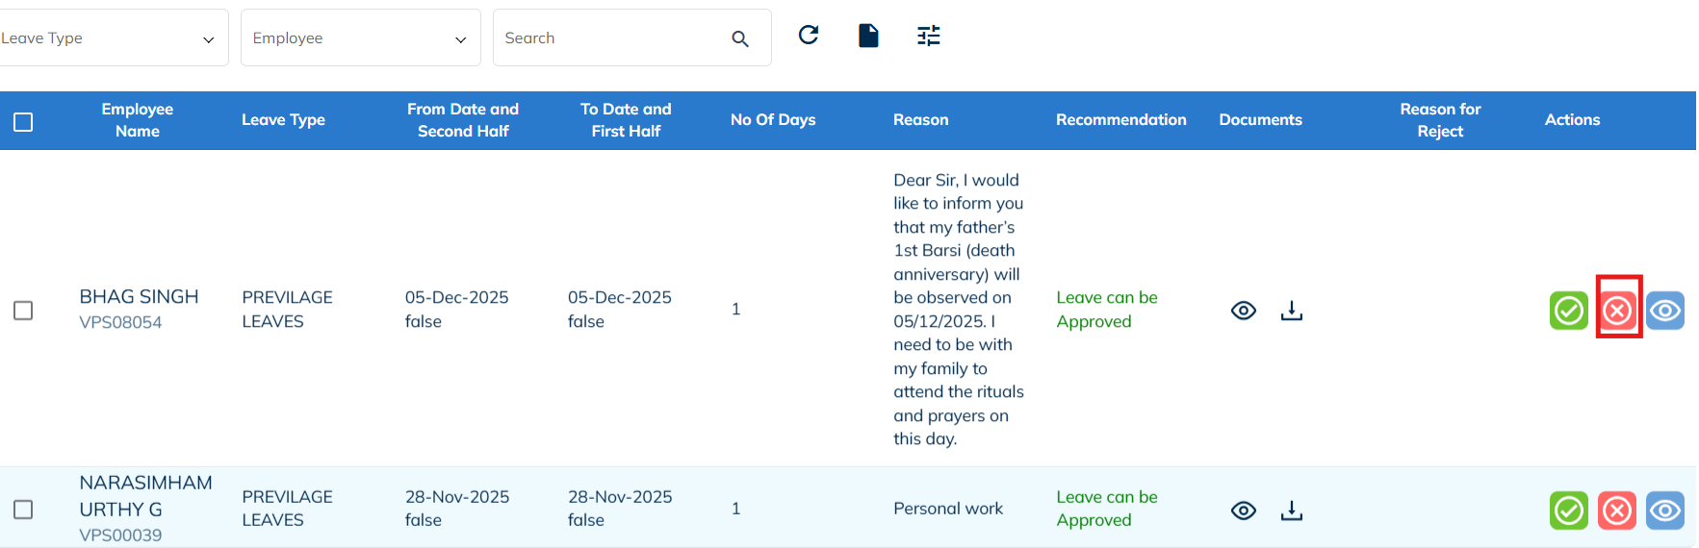

**To view and manage supporting documents**

1. Download any documents submitted by the employee with the leave request.

The document is saved to your device.

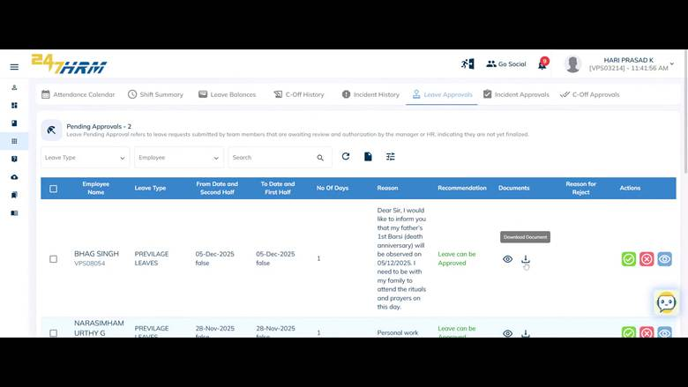

2. Alternatively, click **View Document** to open the document directly in the system.

The document opens in a viewer window.

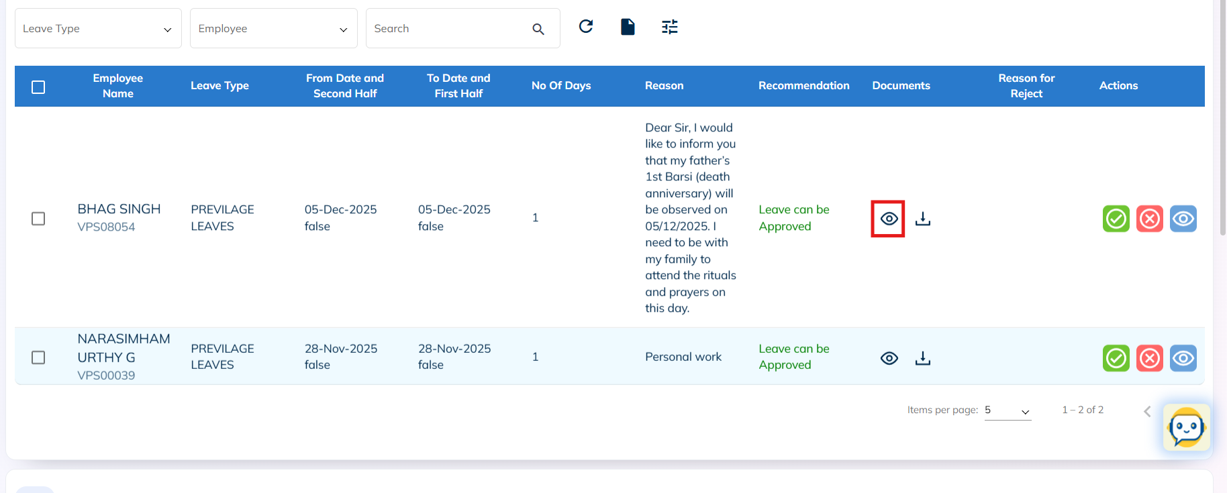

**To customize the leave approvals table**

1. Hide columns by deselecting them (e.g., hide employee name to display only employee ID and message columns).

The selected columns are removed from the table view.

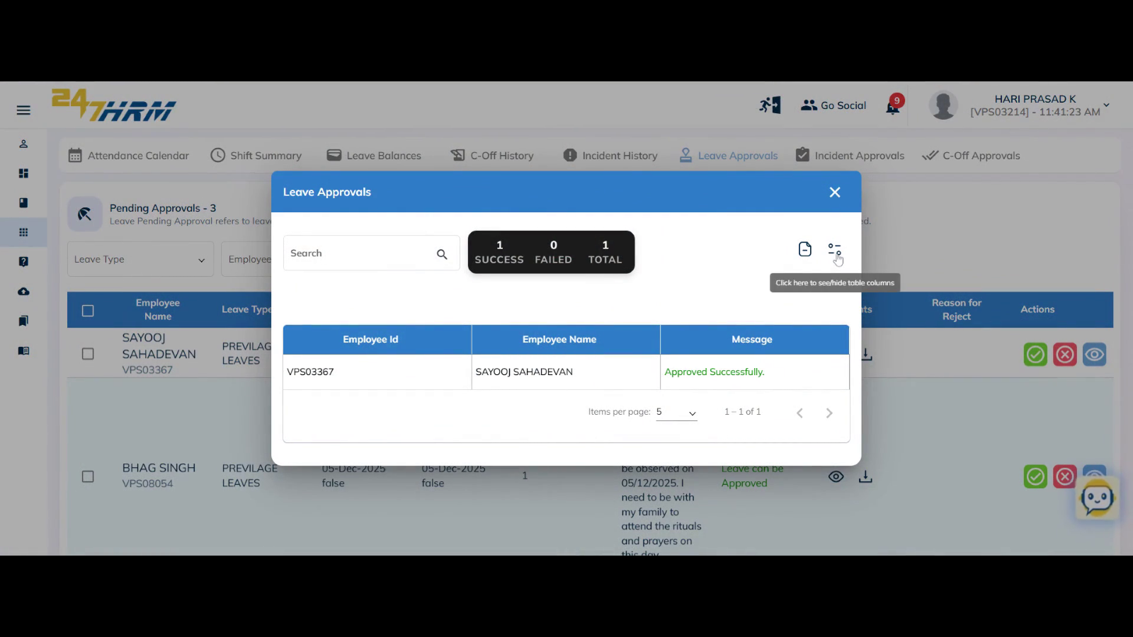

2. On the main window, deselect the **Reject Reason** column if you do not wish to display it.

The Reject Reason column is hidden from view.

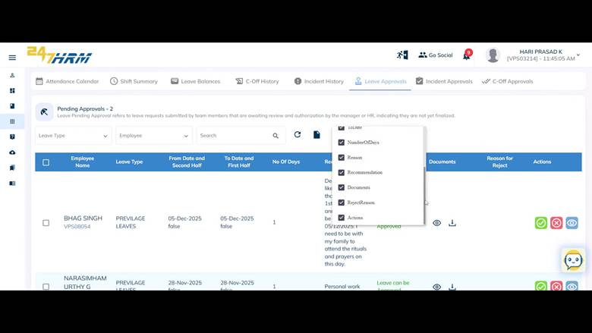

**To filter and search leave requests**

1. Use the search bar to find a specific leave type or employee name.

The table updates to show only matching records.

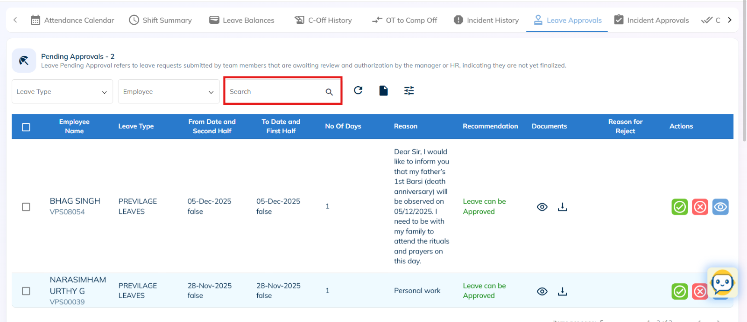

2. Apply filters by selecting leave type or employee name.

The table displays filtered results based on your selections.

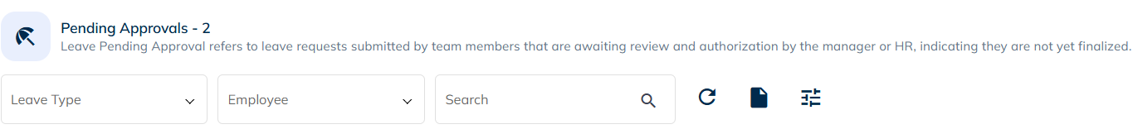

3. Reset filters to return to the full list of leave requests.

All records are shown again.

**To export leave data**

1. Click **Generate Excel** or **Export** to download the table as an Excel file.

The data is exported and saved for further analysis.

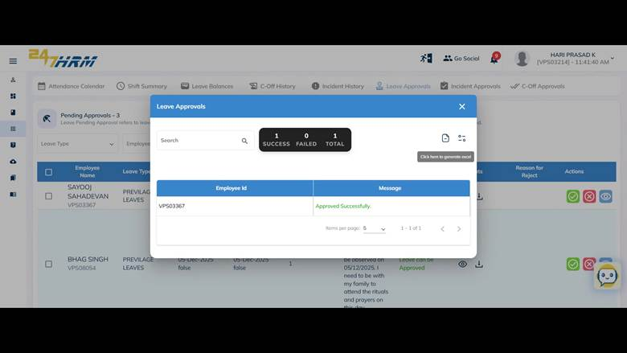

**To review approved leave history**

1. Scroll down to the **Approved History** section.

This section lists leaves approved for each employee, including employee name, leave type, application date, leave date, reason, recommendation, and number of days taken.

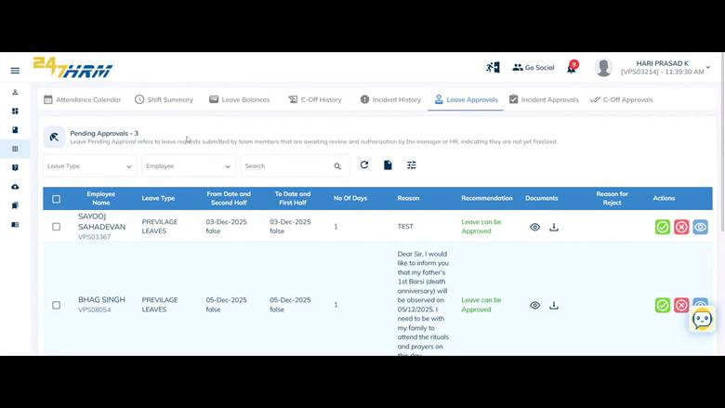

2. Review or download attached documents from approved leave records.

The document is downloaded or viewed as needed.

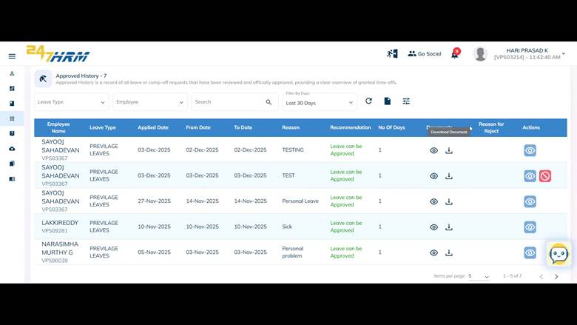

**To review employee leave utilization for a selected period**

1. Open the **Employee Leave Utilization** tab.

The tab shows the number of leaves taken by an employee in the selected period (default is current month).

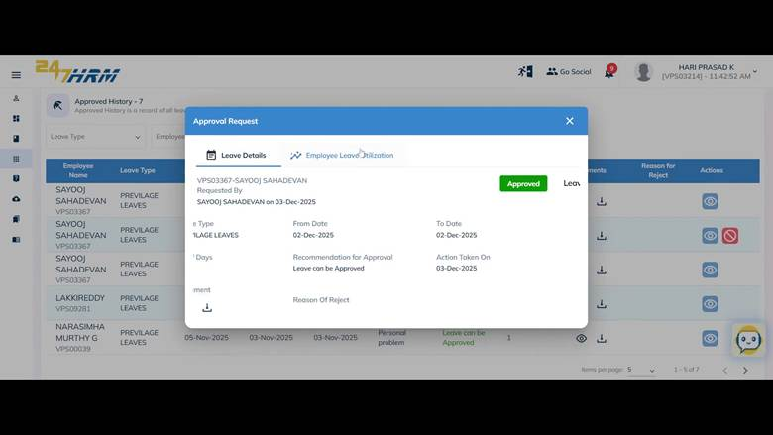

**Verification**

After approving or rejecting leave requests, check the **Pending Approvals** section to confirm the request is no longer listed.

The leave status should update accordingly, and the action should be reflected in the Approved History or with the rejection reason displayed.

**If the Problem Persists**

If you are unable to approve or reject leave requests, or if the data does not update as expected, contact your HR or IT support team. Provide screenshots of the issue, details of the affected employee, and any error messages encountered.

**FAQs**

### What is the Leave Approvals page used for?

The Leave Approvals page allows managers (L1 and L2) or HR Managers to review, approve, reject, or view employee leave requests. It also provides access to leave utilization data and supporting documents.

### How do I access pending leave requests?

Go to **My Applications → Leave & Attendance → Leave Approvals**. The **Pending Approvals** section will display all pending leave requests.

### Where can I view previously approved leave requests?

Scroll down to the **Approved History** section to review all past approved leave requests.

### How can I filter leave requests beyond just searching?

You can apply filters such as:

* Leave Type
* Employee Name
* Date Range  
   After applying filters, the table will update to reflect the narrowed results.

### How do I verify that my approval or rejection was successful?

After taking action:

* The leave request should disappear from **Pending Approvals**
* Approved requests move to **Approved History**
* Rejected requests show the rejection reason in the “Reason for Reject” column